WHAT IS THE EU?
The European Union is not a state but a unique economic and political partnership between European countries that want to build a future together. How is it that 28 different countries have decided to come together in one union? What do Europeans have in common? We share a continent and much more…..

Question 1
Europeans have always interacted with each other, by exchanging goods and ideas, fighting over territory and concluding treaties. Our common history and cultural heritage have shaped the way we think, feel and behave to this day.
Which of these statements is FALSE?
- Many words in European languages have common roots, for instance 'Europe' and 'democracy' (Greek) or 'union' (Latin).
- Many art forms originated in one European country and spread across the continent and often even further… Jazz music is one example.
- European countries have developed a set of common values, such as freedom, democracy and the rule of law.

Question 2
Unfortunately, European history has often been marked by armed conflicts. The two world wars in the 20th century killed millions of people, and there were only 20 years of peace between them. Finally some European countries decided to work together with a clear and brave vision: no more wars!
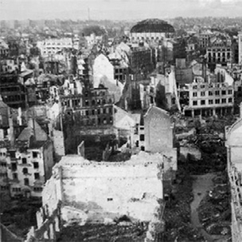
Which of these statements is FALSE?
- In the aftermath of the Second World War, the initial idea was to secure peace in Europe by bringing nations together as equals.
- The founding members of the EU were Belgium, France, Germany, Italy, Luxembourg, the Netherlands and Spain.
- More than 80 million people were killed in the two world wars, many of whom were civilians.

Question 3
The six founding members started to rebuild Europe together. To prevent further armed conflicts, the countries decided to jointly control their coal and steel industries so that they could not secretly arm themselves against each other. Building on the success, the six founding countries aimed at expanding the cooperation to other economic sectors. They created the European Economic Community. And then more countries wanted to join.
Which of these statements is FALSE?
- In 1957, the founding members signed the ‘Treaty of London’, creating the European Economic Community.
- In 1973, three new members were welcomed: Denmark, Ireland and the United Kingdom.
- It was in 1993 that the current name 'European Union' was first introduced

Question 4
One of the EU's fundamental values is democracy. This means that only democratic countries can become members. In the 1970s, three European countries, previously ruled by dictatorships, became democratic and could ask for EU membership.
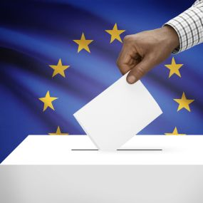 | Which of these statements is FALSE?  - Greece, Spain and Portugal were eligible to join the EU once democracy had been established in their countries.  - Greece became a member in 1981. Spain and Portugal followed five years later (1986), bringing the membership total to 12.  - The European flag has 12 gold stars, because at the time it was introduced there were 12 Member States.

Question 5
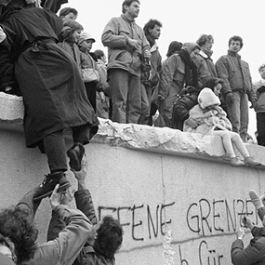
After the Second World War, Europe became divided into east and west. The Berlin Wall, which separated East and West Berlin for almost three decades, was a symbol of this division. After the fall of the Berlin Wall, Germany was reunified in 1990. A few years later three more countries joined the EU.
Which of these statements is FALSE?
- Resistance against communist rule in central and eastern Europe led to the fall of the Berlin Wall in 1989.
- The reunification of Germany in the following year brought West Germany into the European Union.
- In 1995, Austria, Finland and Sweden joined the European Union.

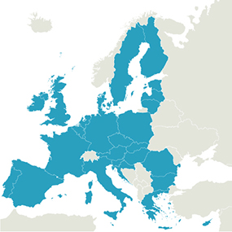
Question 6
The fall of the Berlin Wall ended the Cold War between east and west Europe. It cleared the way for the central and eastern European countries that were previously controlled by the former Soviet Union to reform their societies and join the EU. The EU has now 28 Member States. Which countries have joined and how does the EU deal with so many languages?
Which of these statements is FALSE?
- In 2004, ten countries joined the EU: eight countries from central and eastern Europe — the Czech Republic, Estonia, Hungary, Latvia, Lithuania, Poland, Slovakia and Slovenia — and the Mediterranean islands of Cyprus and Malta.
- Bulgaria and Romania followed three years later, in 2007. Croatia joined in 2013 and is the latest member of the EU.
- The EU has three official languages; English, French and German.

Question 7
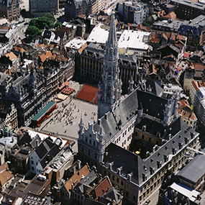
The EU has enjoyed more than 60 years of peace and has grown from six to 28 Member States. Let's see if you can recognize some of them.
Which Member State…
… is one of the six founding members of the EU;
… has three official languages (Dutch, French and German); and
… hosts many European institutions in its capital city?
Germany France Belgium

Question 8
Which Member State…
… has a long history of exploration and discovery;
… became a member of the EU in 1986;
… is the westernmost state on the European continent?
Portugal Spain Italy
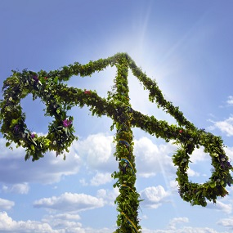
Question 9
Which Member State…
… is one of seven monarchies in the European Union;
… is partly located north of the Arctic Circle and is known for its Midsummer celebrations; and
… joined the European Union in 1995, together with two other countries?
Sweden Finland Estonia

Question 10
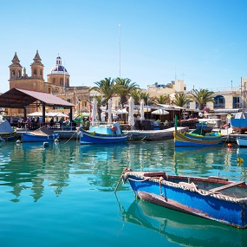
Which Member State…
… has two official languages, including English;
… became a member of the European Union in 2004, together with another Mediterranean island and eight countries from central and eastern Europe;
… is the smallest of the 28 EU Member States?
United Kingdom Malta Cyprus

 | Question 11
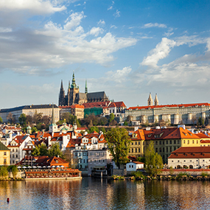 | Which Member State…  … became a separate state in 1993 after Czechoslovakia split into two countries;  … joined the European Union in 2004, together with nine other countries;  … borders Germany to the west.  Slovakia Poland Czech Republic

Question 12
Which Member State…
… fought a war of independence between 1991 and 1995;
… is known for the eye-catching jerseys of its national sports' teams which feature a red and white checkerboard pattern; and
… is the latest member of the European Union, joining in 2013.
Bulgaria Croatia Slovenia

HOW DOES THE EU WORK?

Who holds the power in Europe?
You often hear in the news that 'Brussels' has decided this and that. What does it actually mean? Who or what is 'Brussels'? Let's have a look inside the 'machine room' of the EU to see how it all works.

Question 1
The European Union's aim is to promote peace, its values and the well-being of its peoples. These European values unite all the Member States – only countries that recognise them can belong to the Union. One of the fundamental values of the EU is democracy. Only democratic countries can become members.
Can you recognise some of the other European values in the list below? But watch out; one of them is not correct.
Which of these is NOT a value on which the EU is founded?
- Respect for human dignity and human rights
- Free trade
- Freedom

Question 2
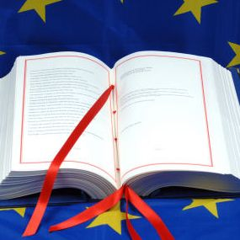
Like many other organisations, the objectives and rules of the EU are agreed by its members. The EU treaties govern how decisions are made and in which areas the EU acts jointly. Every action taken by the EU is founded on treaties that have been negotiated and approved voluntarily and democratically by all EU countries. The technical term for this is 'ratification', which means that the treaties are approved by the national parliaments or by referendum.
In which city was the latest treaty signed?
- Rome
- Amsterdam
- Lisbon

Question 3
The European Union cannot decide on everything. The EU countries have delegated responsibilities to the EU only in specific policy areas, such as consumer protection, environment and trade. For many of these areas both the EU and the EU countries are able to pass laws. The overall principle is that the EU should act only when a problem can be solved more efficiently at EU level than by national, regional or local action.
Listed below are policy areas for which the EU has been given responsibility by the EU countries. For one of them, the EU cannot pass any laws.
Do you know which is it?
- Energy, environment and agriculture
- Transport and the internal market (i.e. the EU's single market offering free movement of goods, services, people and capital)
- School education and training

Question 4
Brussels is the capital of Belgium, often referred to as the capital of Europe. Many European institutions have their headquarters here. When 'Brussels' has decided something, what exactly does it mean?
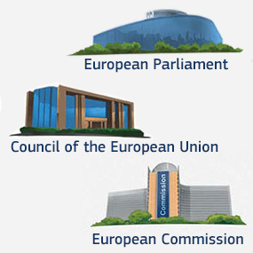
Which of these statements is FALSE?
- All decisions at EU level are taken by the European Commission. It alone decides on new EU laws and actions.
- The European Commission proposes new legislation, but it is the Council and European Parliament that make the final decision on these proposals. They pass the EU laws.
- If Council and Parliament cannot agree on a piece of proposed legislation, there will be no new law.
Question 5
The European Commission has 28 members, known as 'Commissioners', i.e. one person from each Member State. They are appointed by national governments for five years and must be approved by the European Parliament. They are responsible for specific policy areas, such as energy, development or trade, just to mention a few.
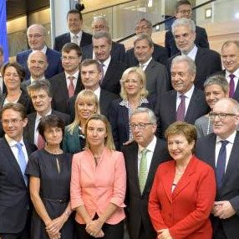 | Which of these statements is FALSE?  - The European Commission proposes new EU laws.  - The Commissioners represent the views of their own country.  - Civil servants working for the European Commission are nationals from all EU countries.

Question 6
When decisions are taken in the EU you, as a citizen, are represented by the European Parliament. It has 751 members from all EU countries. Members of different nationalities but of the same political persuasion work together in political groups.
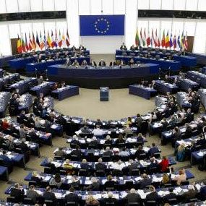
Which of these statements is FALSE?
- Countries with a large population have more members than countries with a small population.
- The Members of the European Parliament are appointed by the national parliaments of the EU countries.
- Together with the Council, the European Parliament adopts EU laws and decides how the EU budget is spent.
Question 7
The EU countries are represented by the Council of the European Union. In the Council, ministers from all Member States meet to discuss EU matters, and make decisions on EU policies and laws. The minister attending depends on the topic under discussion. For example, if the topic is the environment, the environment ministers from all 28 EU countries will meet.
Thus, when decisions are taken at European level, your country is represented by your government. Remember this when you vote in your national elections. Your vote will also influence decisions taken in Brussels.
Which of these statements is FALSE?
- Each minister in the Council votes on behalf of his or her government. The ministers thus promote their respective national interests in the EU.
- The work of the Council is led by each EU country in turn for a period of six months.
- All decisions are taken unanimously
Question 8
Other EU institutions you might have heard of are the European Council, the Court of Justice of the EU, the European Central Bank and the European Court of Auditors.
The European Council brings together the heads of state or government of the EU countries (i.e. presidents or prime ministers). Their meetings are often referred to as 'European summits'. The European Council is chaired by a President appointed for two and a half years.
Which of these statements is FALSE?
- The European Council adopts new EU laws.
- The European Council meets in Brussels at least four times a year.
- The European Council sets the EU's main priorities and overall policy direction.

Question 9
Now you know a lot about the EU institutions, but do you recognise the people working for them?
Here are some clues:
- I am the President of a European institution and have been elected by the European Parliament for a period of 5 years on the basis of my political guidelines.
- I 'head up' a team (known as the 'college') which has one member from each EU country. Our task is to promote the interests of the European Union as a whole.
- I am a former Prime Minister of my home country of Luxembourg.
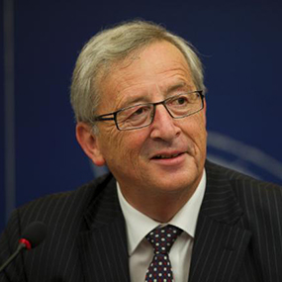 | Who am I?  - You are Donald Tusk, President of the European Council.  - You are Jean-Claude Juncker, President of the European Commission.  - You are Antonio Tajani, President of the European Parliament.

Question 10
- I coordinate and carry out the EU's policy towards other countries and organisations.
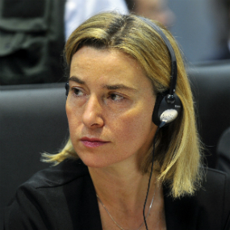
- I represent the EU at international fora such as the United Nations.
- I used to be Minister of Foreign Affairs and International Cooperation in my home country of Italy.
Who am I?
- You are Emily O'Reilly, the European Ombudsman.
- You are Cecilia Malmström, European Commissioner for Trade.
- You are Federica Mogherini, High Representative of the Union for Foreign Affairs and Security Policy.
 | Question 11
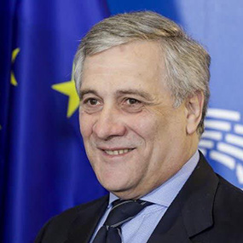 | - I am President of a European institution that represents EU citizens.  - My institution debates EU laws and the EU budget, and I sign the budget to approve it.  - I am from Italy and have been a member of two European institutions.  Who am I?  - You are Mario Draghi, President of the European Central Bank.  - You are Donald Tusk, President of the European Council.  - You are Antonio Tajani, President of the European Parliament.

Question 12
- I am the President of a European institution, and have been appointed for two and a half years.
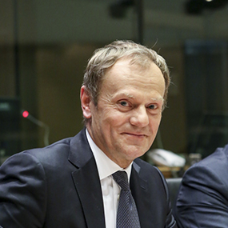
- I chair the meetings with heads of state or government from the 28 Member States.
- I am a former Prime Minister of my home country of Poland.
Who am I?
- You are Donald Tusk, President of the European Council.
- You are Jeroen Dijsselbloem, President of the Eurogroup.
- You are Mario Draghi, President of the European Central Bank.

HOW IS THE EU RELEVANT TO US?
Some people say the EU does not do enough; others say it interferes in everything. Many say the EU does not concern them. What is your opinion? Do you think that the EU is remote and not relevant to you?
Let's follow Anna, a young Swedish girl, to see how the EU is relevant to her everyday life

Question 1
The EU has created an internal market where people, goods, services and money can move around freely within the EU's 28 Member States. This internal market is often called the single market and concerns more than 500 million EU citizens.
What does this mean for Anna? She has just finished school and would like to improve her language skills. She enrols at a language school in southern France. Help her to prepare for this new adventure.
Which of these statements is FALSE?
- As an EU citizen Anna has the right to study in any other EU country. She can start packing her suitcase and take off for France!
- Anna needs to apply for a temporary residence permit before going to France.
- Anna could take on a part-time job in France to finance her studies. EU citizens have the right to work in any other EU country.

Question 2
The EU's single market has transformed the way Europeans live, work, travel, study and do business. Nowadays, young and old can decide to spend part of their lives in another EU country. Most people now take this freedom for granted, but our grandparents could only dream of it. Many laws have been put in place to make these new opportunities a reality. In France, Anna meets Pawel, an Erasmus+ student from Poland.
Which of these statements is FALSE?
- The Erasmus+ programme helps young people to move around Europe. It provides financial and organisational support for a period of time abroad.
- This EU programme is only for university students and does not include other ways of learning.
- More than 5 million young people have participated in the Erasmus programmes.

Question 3
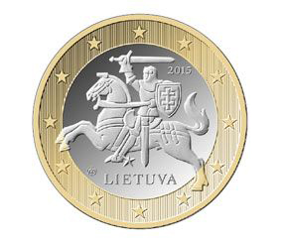
In 2002, euro banknotes and coins were introduced. The euro is used in 19 EU countries, and now more than 337 million EU citizens have it as their common currency. There are a number of advantages to having a common currency in a single market, such as allowing people from different countries to do business together more easily. Consumers can also compare prices better at home and abroad and on the internet. The euro coins have a common side, portraying a map of Europe, but each country has its own design on the other side. Anna tries to guess where the different coins come from. Help her with this one.
From which country is this 1 euro coin?
Lithuania Latvia Luxembourg

Question 4
A single market of 28 countries and with more than 500 million people means more choice for consumers and cheaper products. But if you have a single market in which people can buy and produce things wherever they want, there must be common rules. You need to feel secure in the knowledge that a product is safe wherever you buy it (including on the internet) and that you, as a consumer, have certain rights. Anna needs to buy new headphones in France and hopes that they will be safe to use. She also does some shopping online. Once she subscribed to a Swedish magazine, and then changed her mind shortly afterwards.
How are consumers protected in the EU? Which of these statements is FALSE?
- To be sold within the EU's single market, products must fulfil EU-wide safety and environmental requirements.
- Under EU rules you have the right to a minimum 2-year guarantee for consumer products such as electronic goods.
- In the EU, you have the right to withdraw from a purchase made elsewhere than in a shop within 14 days. This does not apply to online purchases.

Question 5
The EU has removed many obstacles and barriers between countries and their people. One example is Europe's airlines. The EU has gradually broken up national monopolies and permitted competition. Nowadays all EU airlines may operate air services on any route within the EU. For example, you can choose to fly from France to Poland with a German or Irish airline.Anna would like to visit the home town of her new Polish friend Pawel. She might even find a cheap direct flight.
Which of these statements is FALSE?
- The liberalisation of the aviation sector has made flights in Europe much cheaper.
- More cities and regions are now served by airports and there are more direct flights between them.
- When flights are delayed or overbooked you have no right to compensation.

Question 6
Travelling is now much easier in Europe. Most EU countries have taken away their border controls. They have signed up to the Schengen Agreement, named after the village in Luxembourg where the first agreement to abolish border controls was signed. This means that you can move between the 'Schengen countries' without your passport. Anna has bought a ticket to Poland, and is excited about her trip. But she has an unwelcome surprise when she finds out that her passport has expired. Does Anna need to cancel her trip?
Which of these statements about Schengen is FALSE?
- Both Poland and France are among the 22 EU countries that have signed the Schengen agreement, and Anna can travel without her passport.
- Poland is not a Schengen country, so Anna cannot pass the border control without a valid passport.
- Four non-EU countries also belong to the Schengen area, namely Iceland, Liechtenstein, Norway and Switzerland.

Question 7
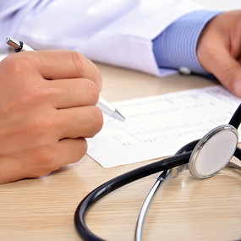
Europeans travel around Europe more than ever before. Sometimes things do not turn out as expected. To protect EU citizens who fall ill or have an accident when visiting another EU country, the EU has introduced a European Health Insurance Card. Anna has a fantastic time in Poland, but during a visit to one of the many beautiful monuments, she falls and twists her ankle. Not a nice thing to happen anywhere, but even less so when you are abroad.
Which of these statements is FALSE?
- The European Health Insurance Card gives Anna the right to private healthcare free of charge.
- Anna can receive public health care and pay the same fees as locals with her European Health Insurance Card.
- The format of this card is the same in all Member States, bearing a European symbol.

Question 8
The EU is about connecting countries and people: it abolished roaming charges in June 2017. When travelling in the EU you pay domestic prices for phone-calls, SMS and mobile internet (Roam Like at Home).
While in France, Anna stays in touch with her friends and family at home on her smartphone. She calls and texts her friends and family and uses social media apps to share pictures and experiences with them. What about Anna's mobile roaming costs?
Which of these statements is FALSE?
- Anna can Roam Like at Home with her Swedish smartphone without any limitations even if she stays in France for four months or longer.
- As long as you travel periodically and spend more time in your home country than abroad, you can fully benefit from Roam like at Home.
- Roam Like at home applies automatically. You don't need to contact your operator to activate it.

Question 9
Environmental pollution and climate change know no borders and cannot be tackled by countries alone. EU countries have therefore decided to deal with these issues acting jointly at EU level. Over the past decades, the EU has put in place a broad range of environmental legislation. As a result, air, water and soil pollution has been reduced significantly. Today, EU citizens enjoy some of the best water quality in the world and over 18% of EU's territory has been designated as protected areas for nature. Anna is not sure about the quality of water in France and Poland. Can she safely drink the tap water and swim in the lakes and in the sea?
Which of these statements is FALSE?
- There are EU-wide minimum standards on drinking and bathing water which all EU countries must respect.
- During the bathing season, EU countries must inform the public promptly about the quality of bathing water.
- Just above 50% of bathing sites in the EU meet the minimum standards for water quality.

Question 10
The EU invests in Europe's cities and regions. It co-finances many projects with the aim of creating economic growth and jobs, to improve the environment and to reduce regional disparities in Europe. The resources are used, for example, to finance roads, rails and broadband and to support research projects and start-ups. The French city where Anna lives participates in a European project. Together with other European cities, it is developing greater sustainable use of energy in order to become a low energy city.
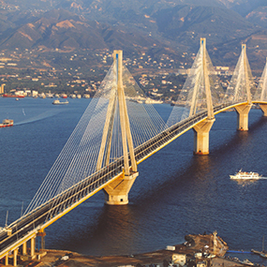 | Which of these statements is FALSE?  - One third of the EU budget is spent on projects benefitting European cities and regions.  - Thousands of projects are co-financed every year and around 15 million people take part in these.  - Only the least-developed EU countries can benefit from EU funding.

Question 11
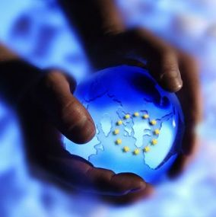
Europe is part of a world that is growing closer and closer together. This is why the EU also has a responsibility to engage at an international level. It does this to safeguard its own interests, and to exert a positive influence on global development. If you want to influence international negotiations - whether it be on trade, climate change or diplomacy – it is better to speak with one voice. Anna meets many people in France, some from non-EU countries. In a discussion with some visitors from Australia, she makes three statements about the role of Europe in the world.
She is wrong about one thing; do you know which?
- The EU is the largest single donor of development aid in the world.
- Europeans make up 15 % of the global population.
- The EU stands for democracy and the rule of law throughout the world and was awarded the Nobel Peace Prize in 2012.

Question 12
Back in Sweden, Anna tells her grandmother about her European adventures. Her grandmother says that like most things, the EU also has a cost. So they try to find out more about the size of the EU budget and how the money is spent.
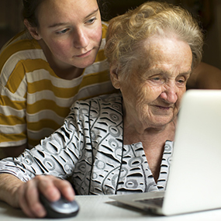 | Which of these statements is FALSE?  - In 2016, the EU budget is € 155 billion. This corresponds to 10% of the EU countries' GDP - the total value of all goods and services produced in the EU.  - Around 6% of the EU budget is spent on administration. 94% goes to the EU countries for policies and programmes that benefit citizens directly, and to countries outside the EU.  - At least 20% of the budget for 2014-2020 should be spent on actions related to climate change.

WHAT IS ON THE EU'S AGENDA?
The European Union has achieved what it was originally created for: peace between its Members, which has now lasted for more than 60 years. This is all fine, you might think, but where are we heading now? How does the EU tackle the challenges of today?
Let's have a look at some of the 'hot issues' the EU is working on.

Question 1
The European Commission represents the interests of the European Union as a whole and makes proposals on what to do at EU level. In 2014, Jean-Claude Juncker was elected as Commission President by the European Parliament on the basis of a political programme focused on 10 key priorities. Let's have a look at some of these and see if you also think they are important.
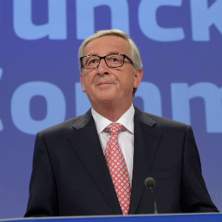
Which of the following is NOT a priority of the EU?
- We should have the same education in maths, history and English all over Europe.
- We should get Europe's economy growing again to create more jobs.
- We should ensure that we have secure, affordable and climate-friendly energy in Europe.

Question 2
Since the start of the global economic crisis in 2008, Europe has been suffering from high unemployment and slow economic growth. A lack of confidence means that businesses are investing less than they could. If we invest more, the economy will grow and there will be more jobs. But if we only use public funds for investments, it would create public debt. So we must also find more private investors.
This is why the EU has launched a new fund for strategic investments. It will use both public and private sources in a smart way. Every euro put into the fund from public sources will generate about €15 of new investments.
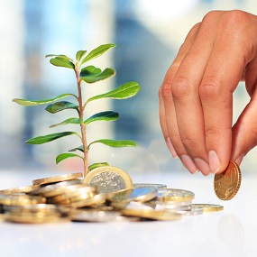 | Which of these statements is FALSE?  - The new fund will mobilise at least €315 billion of investment over three years, without creating new debt.  - The money will be used to build new broadband networks and energy grids. No other projects are planned.  - The ultimate aim is to create more jobs in the EU.

Question 3
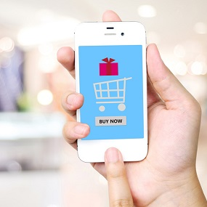
The internet and digital technologies are transforming the world. The EU has created a single market of more than 500 million people. It offers opportunities for businesses and a greater choice and lower prices for consumers. It works well for most physical goods and services. 'Online' there are still a lot of barriers. The EU is working on ways to open up digital opportunities for people and businesses and to create the right conditions for innovative European start-ups.
Which of these statements is FALSE?
- More than 50% of EU citizens shop online from another EU country.
- Only 7% of small businesses sell goods or services to other EU countries.
- One of the main obstacles to e-commerce across borders within the EU is the high price for parcel delivery from one country to another.

Question 4
A fully functional digital single market could contribute €415 billion a year to our EU economy and create hundreds of thousands of new jobs. To make this happen, many barriers still need to be removed. For example, telecoms markets remain isolated and national. A more competitive and open telecoms market would increase the availability of digital services that cross national borders. An example of geographical barriers that still persist online is geo-blocking. Do you know what that is?
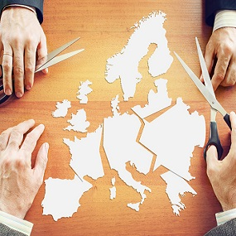 | Which of these statements is FALSE?  - Geo-blocking is the practice of restricting access to internet content based upon the user’s geographical location.  - Geo-blocking means that certain computers cannot be used in other countries.  - Geo-blocking limits consumer choice online.

Question 5
The EU is trying to ensure that energy is climate-friendly, secure and affordable. If we depend too much on buying our energy from one single supplier outside the EU we are vulnerable to disruptions. This is why we need to diversify our energy supplies and rely more on energy produced within the EU.
How much of our energy do we currently import from outside the EU?
- 18%
- 53%
- 72%

Question 6
Climate change is one of the most serious challenges facing humankind, and no country can stop it on its own. The EU is working to promote ambitious global action to limit climate change through the United Nations and other international fora. In 2015, at the UN Climate Change Conference in Paris, a global agreement on the reduction of climate change was reached for the first time. The EU had an important role in making this happen.In the fight against climate change the EU is leading by example through its initiatives aimed at becoming an energy-efficient, low-emission economy. Do you recognise the EU climate and energy targets for 2030?
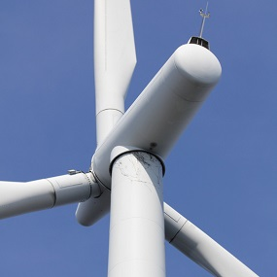 | Which of these targets is NOT correct?  - We should cut greenhouse gas emissions by at least 27%.  - At least 27% of all our energy should come from renewable energy sources.  - We should improve energy efficiency by at least 27%.

Question 7
The European Commission is negotiating a trade agreement with the US. You may have heard of it as TTIP – the Transatlantic Trade and Investment Partnership. The aim is to remove barriers to trade and investment overseas. The agreement is expected to create more growth and employment on both sides of the Atlantic. It will offer new opportunities to 800 million people living in the EU and the US.
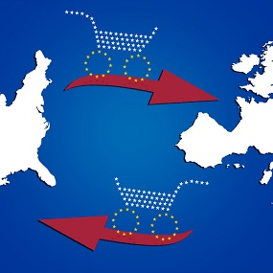
Which of these statements is FALSE?
- Together the EU and US account for more than 40% of the world’s economic output.
- New rules would make it easier and fairer to export, import and invest overseas.
- Many standards in areas such as food safety and health are not the same in the US and in the EU. The US standards are higher.

Question 8
EU citizens are increasingly worried about their security. Terrorism, organised crime, and cybercrime are complex and growing security challenges that cross European borders. Just think of how many of our everyday activities happen on the internet, such as shopping, banking, chatting with friends and playing games. This is true for both adults and children. Companies and governments are also at risk. What do you know about cybercrime?
Which of these statements is FALSE?
- Only economic crime on the internet is called cybercrime, such as stealing credit card details or creating fake online shops to dupe shoppers.
- Cybercrime also consists of the dissemination of illegal content online, such as child sexual abuse material and incitement to terrorism and violence.
- There are over one million cybercrime victims in the world every day.

Question 9
In today's world, hundreds of thousands of migrants and refugees are prepared to risk their lives to enter the EU. Many of them have been forced to leave their country because of war or political persecution. Conflict and crisis in Syria and elsewhere have acted as an immediate trigger, but underlying trends in demographics, climate change, poverty and globalisation in transport and communications all played their part in the record numbers of migrants and refugees arriving in the EU in 2015.
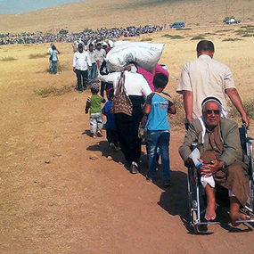
Which of these statements is FALSE?
- Due to their geographical position, certain EU countries, like Greece and Italy, receive the majority of the first arrivals of refugees and migrants in the EU.
- Applications for asylum in the EU have increased dramatically and are unevenly distributed among the EU countries.
- Asylum is granted to people who want to settle in another country in search of a better life.

Question 10
The sudden rise in the numbers of refugees and migrants arriving in the EU has put pressure on Europe. The EU has responded to this situation by taking various actions. For example, the EU has organised ships for search and rescue tasks in the Mediterranean Sea, saving thousands of lives. The fight against criminal networks and people smugglers has also been stepped up, since almost 90 % of the refugees and migrants have paid organised criminals to get them across EU borders. What else is being done?
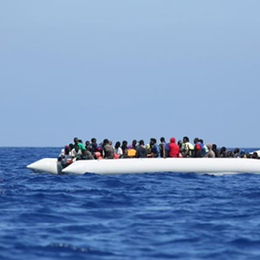 | Which of these statements is FALSE?  - The EU has set up reception centres in Greece and Italy and sent experts to help identify and register people arriving.  - The EU assists EU Member States to return irregular migrants to their home country if they have no right to stay in the EU.  - The EU has financed emergency actions inside the EU, but it does not assist countries outside its borders.

Question 11
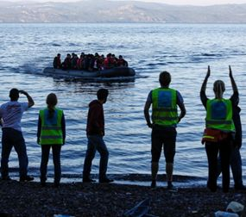
The refugee crisis cannot be solved overnight. The EU is working on new means, such as creating safe and legal ways for asylum-seekers to enter the EU so that they don't have to risk their lives by turning to smugglers and traffickers. EU Member States have also agreed to establish a new European Border and Coast Guard in order to control the EU's external borders more effectively. The EU has set up an action plan on migration with the aim of managing migration better.
What actions are NOT foreseen?
- Reducing the incentives for irregular migration, fighting traffickers and smugglers, and securing the EU's external borders.
- Protecting those in need through a strong common asylum policy.
- Making all migration illegal.

Question 12
Jean-Claude Juncker, the President of the European Commission, said: "I want a European Union that is bigger and more ambitious on big things, and smaller and more modest on small things." To deliver results on the major challenges facing our societies today, the European Commission focuses its work on the 10 priority areas, and makes proposals on new laws and actions related to them.
What about you and your concerns? How can you voice them?
How many Commission proposals are made after consulting the public?
- All of them
- None of them
- About half of them

